nav{

display:inline-block;

margin:10px auto 45px;

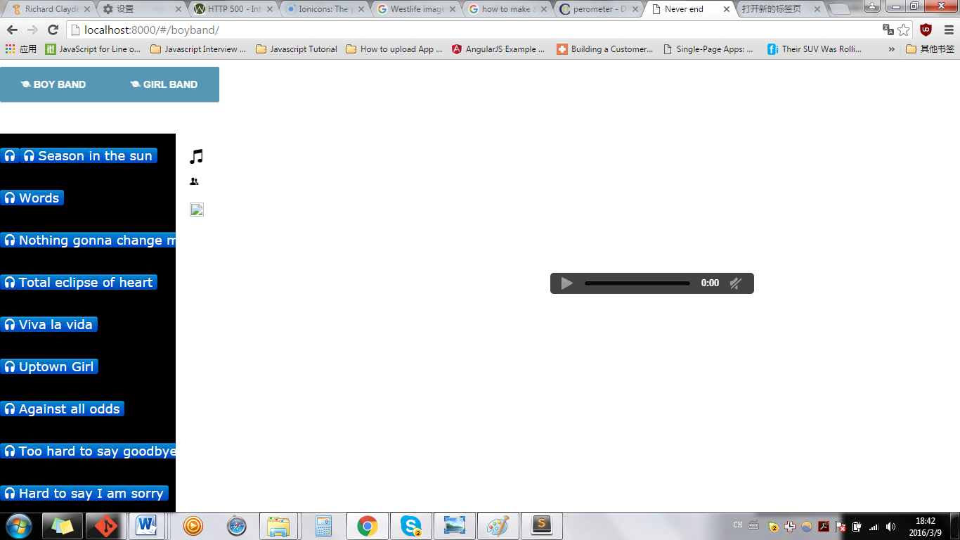

Nav

Not : display:inline-block

margin:10px auto 45px;

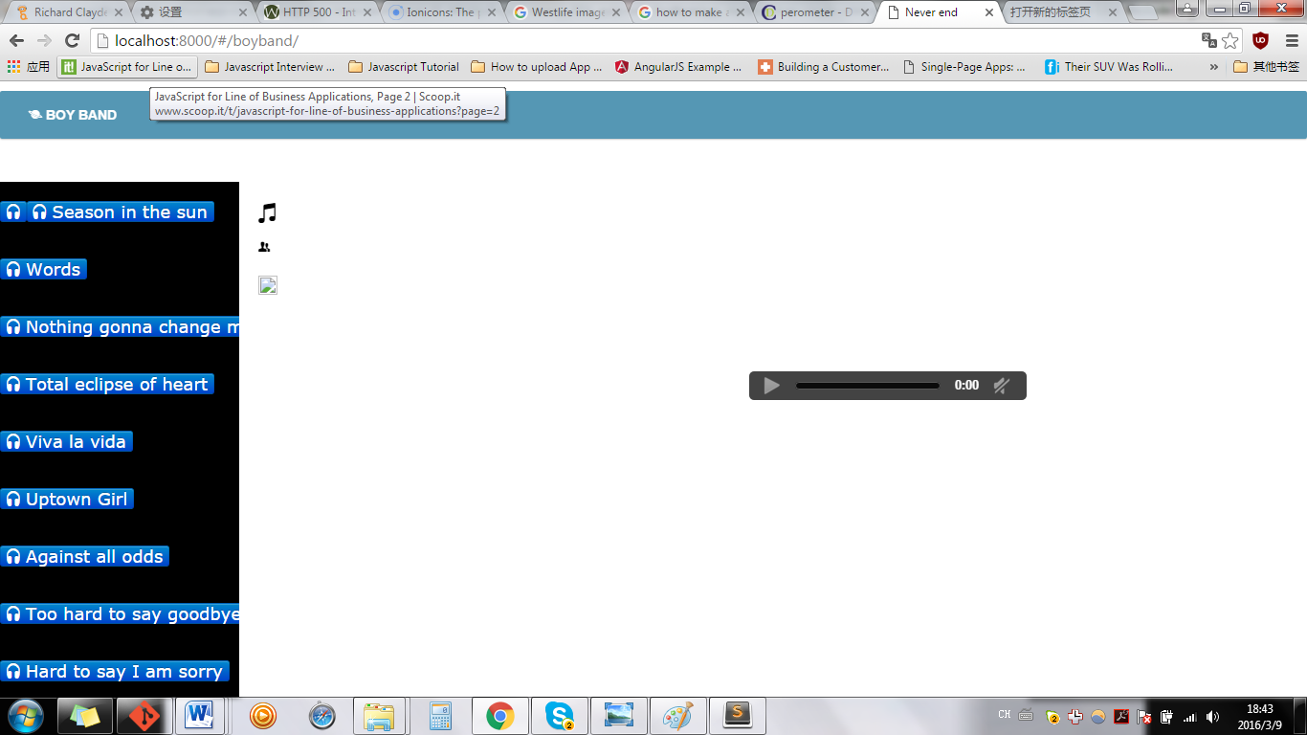

If

margin:10px auto 15px;

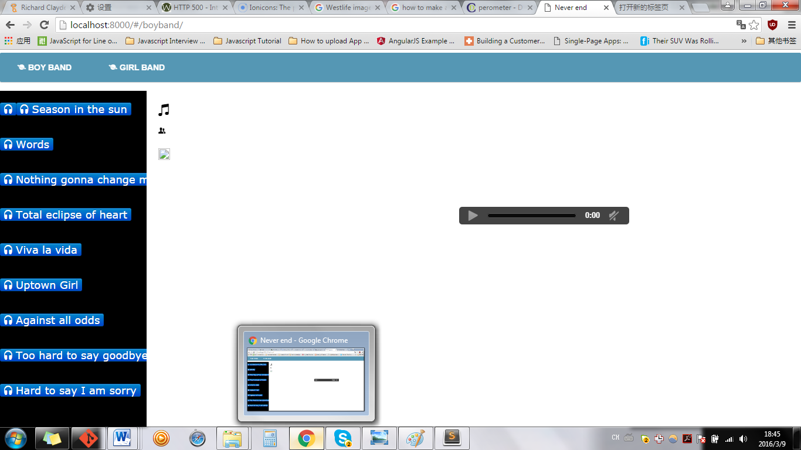

**************************++

nav{

/*display:inline-block;*/

/*margin:60px auto 45px;*/

margin:0px auto 0px;

background-color:#5597b4;

box-shadow:0 1px 1px #ccc;

border-radius:2px;

}

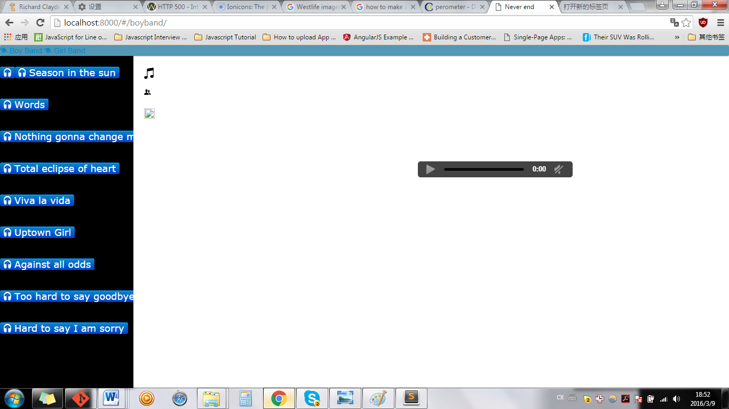

nav{

/*display:inline-block;*/

/*margin:60px auto 45px;*/

margin:0px auto 0px;

background-color:#5597b4;

box-shadow:0 1px 1px #ccc;

border-radius:2px;

}

nav a{

display:inline-block;

padding: 18px 30px;

color:#fff !important;

font-weight:bold;

font-size:14px;

text-decoration:none !important;

line-height:1;

text-transform: uppercase;

background-color:transparent;

-webkit-transition:background-color 0.25s;

-moz-transition:background-color 0.25s;

transition:background-color 0.25s;

}

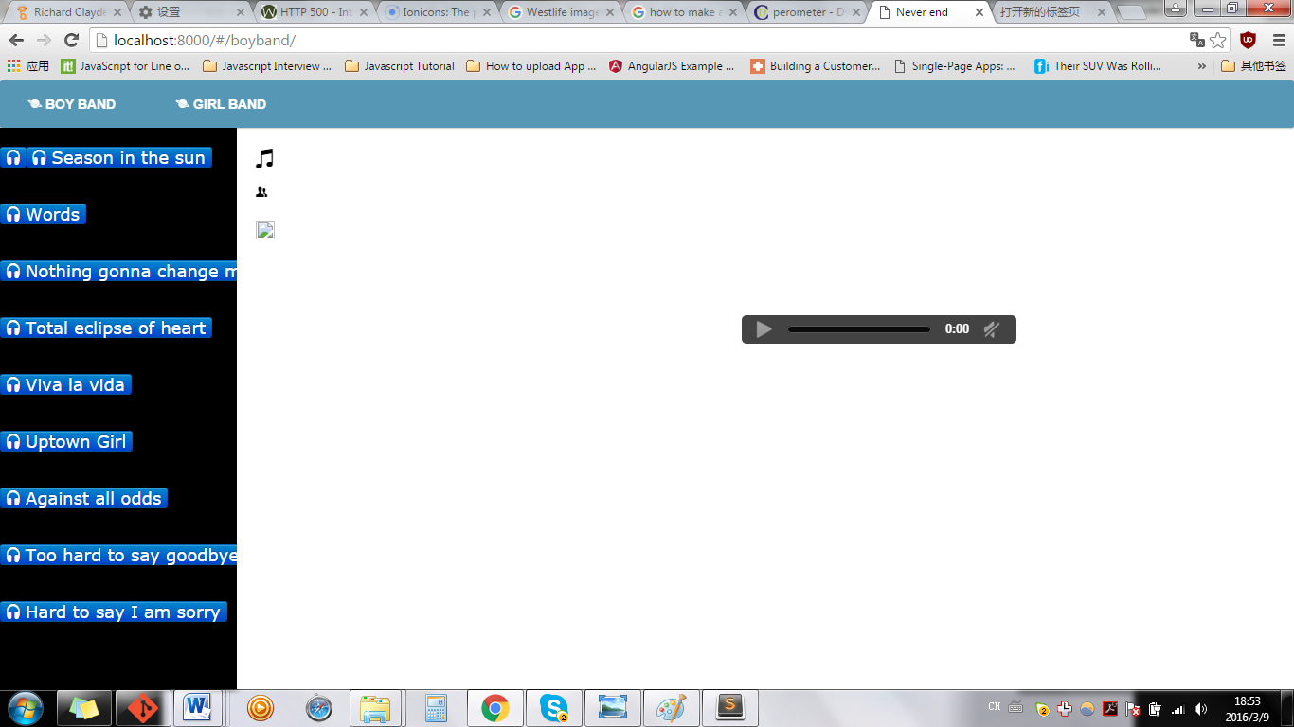

nav{

/*display:inline-block;*/

/*margin:60px auto 45px;*/

margin:0px auto 0px;

background-color:#5597b4;

box-shadow:0 1px 1px #ccc;

border-radius:2px;

}

nav a{

display:inline-block;

padding: 18px 30px;

color:#fff !important;

font-weight:bold;

font-size:14px;

text-decoration:none !important;

line-height:1;

text-transform: uppercase;

background-color:transparent;

-webkit-transition:background-color 0.25s;

-moz-transition:background-color 0.25s;

transition:background-color 0.25s;

}

nav a:first-child{

/*border-radius:2px 0 0 2px;*/

border-radius:2px 0 0 2px;

}

nav a:last-child{

/*border-radius:0 2px 2px 0;*/

border-radius:0 2px 2px 0;

}

nav.home .home,

nav.projects .projects,

nav.services .services,

nav.contact .contact

{

/*background-color:#8ec16d;*/

background-color:#000;

}

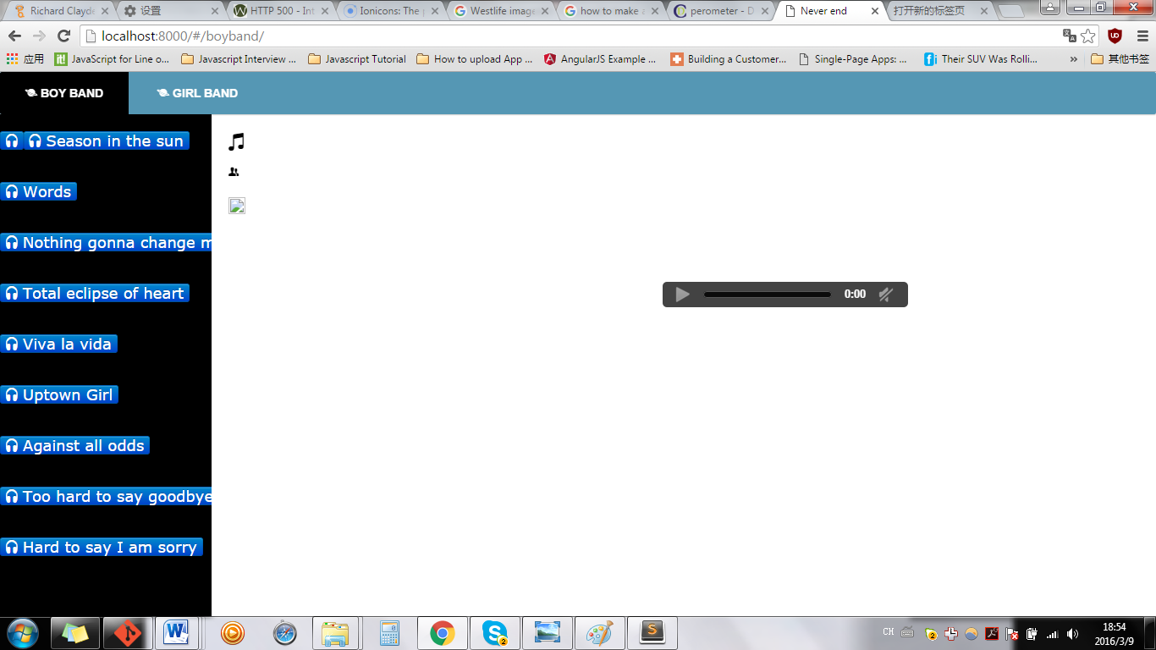

Index.html

<nav class="{{active}}" >

<!-- When a link in the menu is clicked, we set the active variable-->

<a href="#/boyband" class="home" ng-click="active='home'"><i class="icon ion-planet"></i> Boy Band</a>

<a href="#/girlband" class="projects" ng-click="active='projects'"><i class="icon ion-planet"></i> </i>Girl Band</a>

</nav>

CSS file

nav.home .home,

nav.projects .projects,

nav.services .services,

nav.contact .contact

**Html index.html**

<a href="#/boyband" class="home" ng-click="active='home'"><i class="icon ion-speakerphone"></i> Boy Band</a>

<a href="#/girlband" class="projects" ng-click="active='projects'">

<!-- <i class="icon ion-planet"></i> -->

<i class="icon ion-speakerphone"></i> Girl Band</a>

<a href="#/Justin Bieber" class="services" ng-click="active='services'"><i class="icon ion-speakerphone"></i> Justin Bieber</a>

<a href="#/One direction" class="contact" ng-click="active='contact'"><i class="icon ion-speakerphone"></i> One direction</a>

<a href="#/Westlife" class=" services " ng-click="active= services "><i class="icon ion-speakerphone"></i> Westlife</a>

**The result**

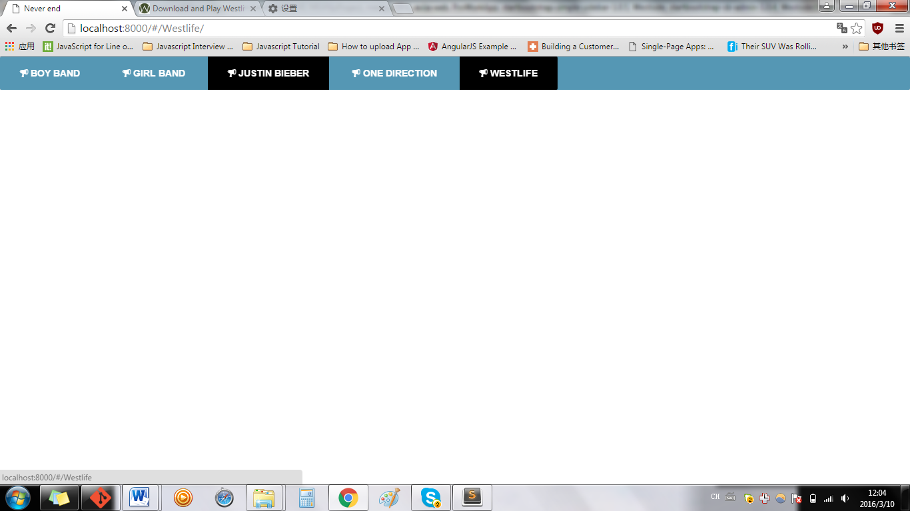

**If change:**

CSS file

nav.home .home,

nav.projects .projects,

nav.services .services,

nav.contact .contact

nav.person .person

**Html index.html**

<a href="#/boyband" class="home" ng-click="active='home'"><i class="icon ion-speakerphone"></i> Boy Band</a>

<a href="#/girlband" class="projects" ng-click="active='projects'">

<!-- <i class="icon ion-planet"></i> -->

<i class="icon ion-speakerphone"></i> Girl Band</a>

<a href="#/Justin Bieber" class="services" ng-click="active='services'"><i class="icon ion-speakerphone"></i> Justin Bieber</a>

<a href="#/One direction" class="contact" ng-click="active='contact'"><i class="icon ion-speakerphone"></i> One direction</a>

<a href="#/Westlife" class=" person " ng-click="active= person "><i class="icon ion-speakerphone"></i> Westlife</a>

**The result**

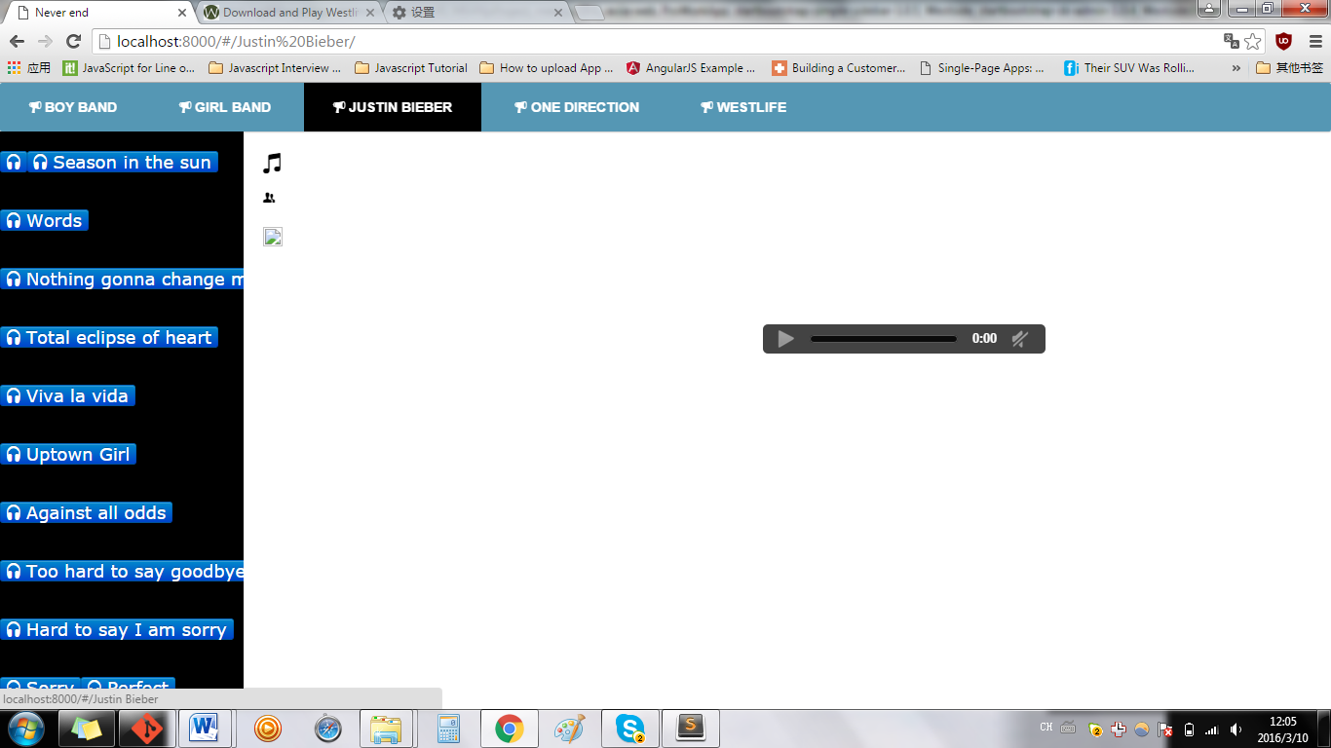

nav a{

display:inline-block;

/*padding: 18px 30px;*/

padding: 10px 20px;

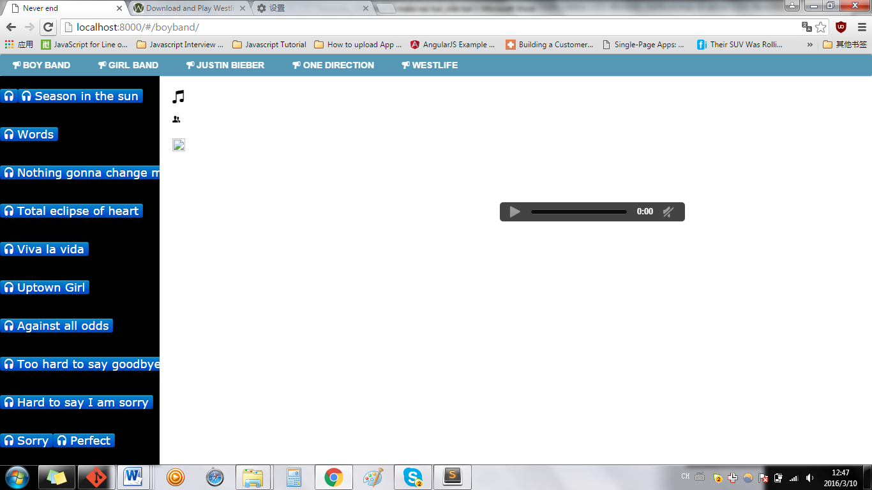

nav a{

display:inline-block;

padding: 18px 40px;

/* padding: 10px 20px;*/

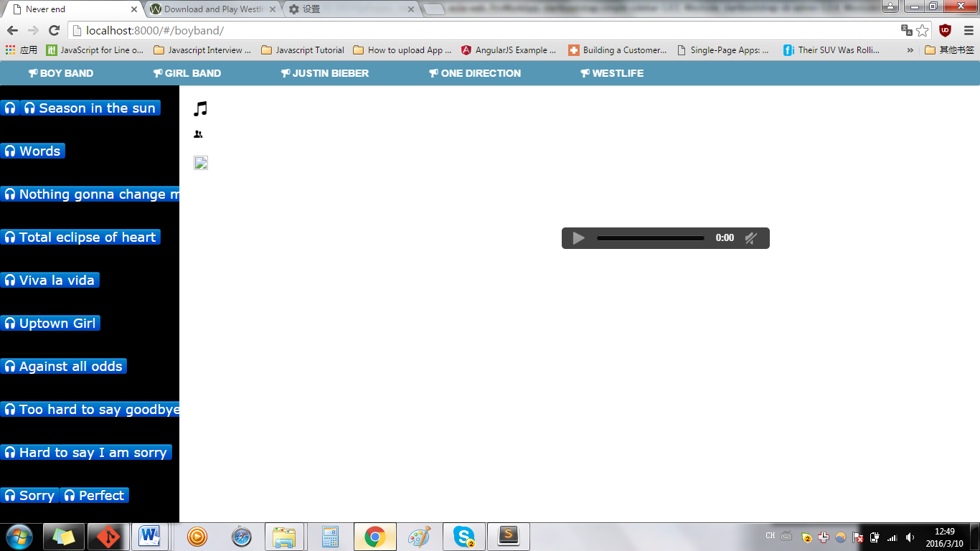

nav a{

display:inline-block;

padding: 18px 40px;

/* padding: 10px 20px;*

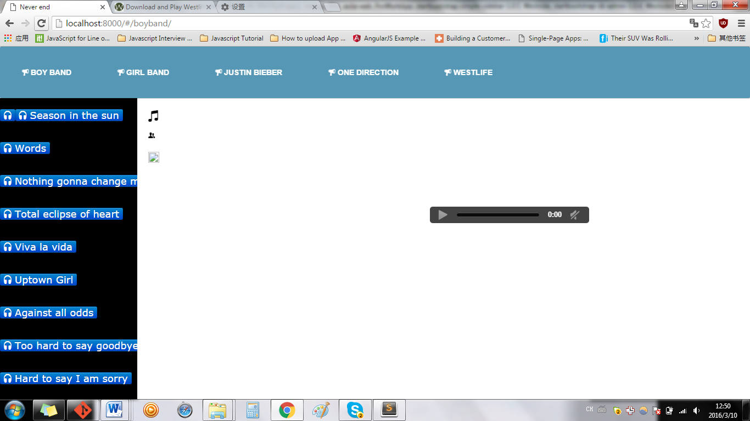

**Simple-sidebar.css**

**.sidebar-nav > .sidebar-brand {**

**height: 65px;**

**font-size: 18px;**

**line-height: 20px;**

**}**

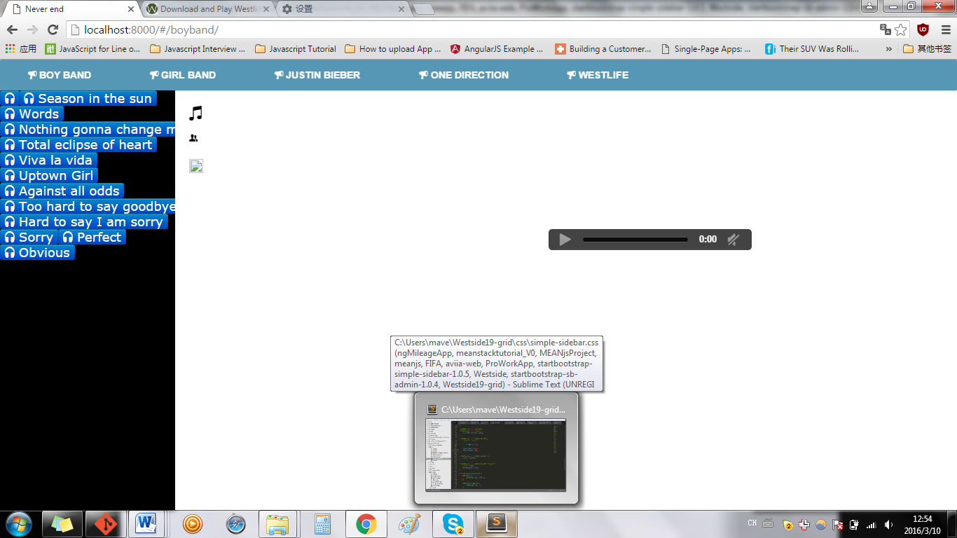

**.sidebar-nav > .sidebar-brand {**

**height: 65px;**

**font-size: 18px;**

**// line-height: 20px;**

**line-height: 40px;**

**}**

